NET731 – Networking
Week 7 Practical: Monitoring Setup
17–23 April | Total Marks: 10
Student Name: | Ewalt Volschenk
Student ID: | 20240226
Submission Date: | 2026/05/15
Azure Subscription ID: | 16c5c302-3140-4e3c-b94b-408f4016e686

Learning Outcomes
By the end of this practical, you should be able to:
- Enable and configure Azure Monitor on virtual machine and network resources
- Navigate the Azure Monitor interface to locate and interpret key metrics
- Identify normal versus abnormal performance baselines for CPU, network, and disk
- Produce a structured monitoring report with supporting evidence

Overview
This week you will configure Azure Monitor across the cloud environment you have been building throughout the semester. Azure Monitor is the central platform for collecting, analysing, and acting on telemetry from your Azure resources. Effective monitoring is not simply about enabling tools — it requires understanding what you are measuring and why it matters.

You are expected to make decisions, explore the interface, and think critically about what you observe. Screenshots must clearly show your own Azure environment — generic or placeholder images will not be accepted.

Before You Begin — Prerequisites
Ensure your VM from previous weeks is running and accessible.
Your Virtual Network (VNet) and Network Security Group (NSG) from Week 5 should be in place.
You will need Contributor access to your Azure resource group.
Allow 10–15 minutes for monitoring data to populate after enabling Azure Monitor.

Task 1 — Enable Azure Monitor (4 Marks)
Azure Monitor needs to be enabled on individual resources before it can collect data. This task covers both your virtual machine and the network resources in your environment.

Task 1.1 — Enable Monitoring on Your Virtual Machine (2 Marks)
Navigate to your virtual machine in the Azure Portal and locate the Monitoring section in the left-hand menu. You will find several sub-options here — explore them before enabling anything.

Think Before You Click
What is the difference between 'Insights' and 'Diagnostics settings' for a VM?
What data will be collected once you enable monitoring? Where is it stored?
Does enabling monitoring have any cost implications you should be aware of?

Once you have explored the options, enable VM Insights or Diagnostics for your virtual machine. Configure it to collect at minimum: CPU metrics, memory (if supported), and disk I/O.

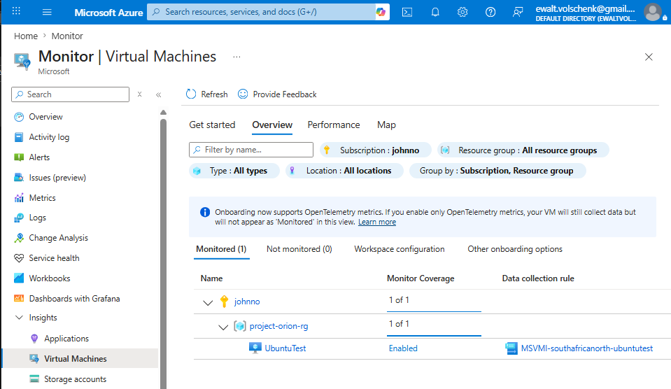

Describe in 2–3 sentences what you enabled and where the collected data will be stored:

Your response: VM Insights was enabled on the virtual machine UbuntuTest via the Azure Monitor Virtual Machines blade, which deployed the Azure Monitor Agent using the data collection rule MSVMI-southafricanorth-ubuntutest. This configuration collects performance telemetry including CPU utilisation, memory, and disk I/O from the VM. The collected data is stored in a Log Analytics Workspace

Task 1.2 — Enable Monitoring on Network Resources (2 Marks)
Repeat the process for your network resources. Both your NSG and your VNet support diagnostic settings.

Consider the following before proceeding:
- What specific log categories are available for an NSG? Which ones would be most useful in a security context?
- What is a Log Analytics Workspace, and why might you need one to proceed?
- If you do not already have a Log Analytics Workspace, you will need to create one — consider which region is appropriate.

[ Screenshot: Diagnostic settings enabled on NSG — show categories selected and destination ]
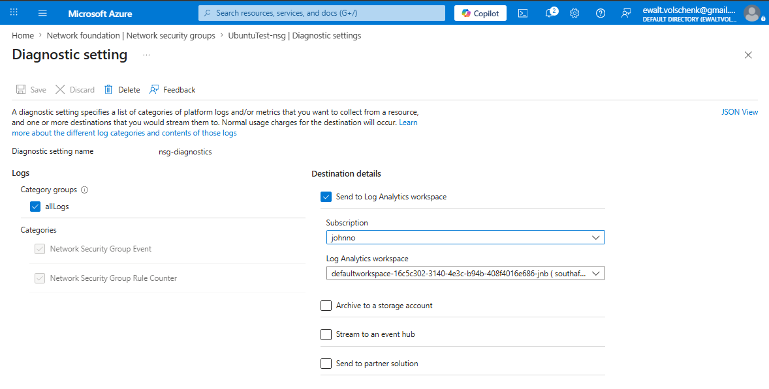

[ Screenshot: Diagnostic settings on VNet or additional network resource ]
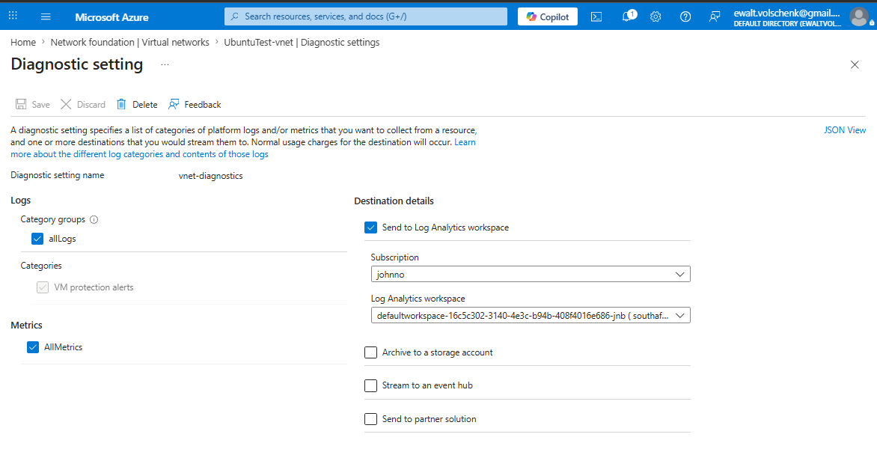

Task 2 — Review Key Metrics (3 Marks)
Now that monitoring is enabled, you will use Azure Monitor's Metrics Explorer to observe and interpret the data being collected. Generating some load on your VM before taking screenshots will produce more meaningful graphs.

Generating Test Load (Optional but Recommended)
On Linux VMs: the 'stress' tool can simulate CPU and I/O load.
On Windows VMs: Task Manager's 'New Task' can run a CPU-intensive process.
Even browsing the web or installing packages from within the VM will generate measurable network activity.
Allow a few minutes after generating load before capturing screenshots.

Task 2.1 — CPU Metrics (1 Mark)
Open Azure Monitor > Metrics and select your VM as the scope. Explore the available metrics before choosing one to display.

- Select an appropriate time range that shows meaningful data (consider: what time range makes sense for a lab exercise?)
- Identify which metric reflects actual CPU usage — consider why there might be more than one CPU-related metric
- Add annotations or use the pin feature to highlight any interesting patterns you observe

[ Screenshot: CPU metrics chart — VM scope, showing usage over a meaningful time period ]
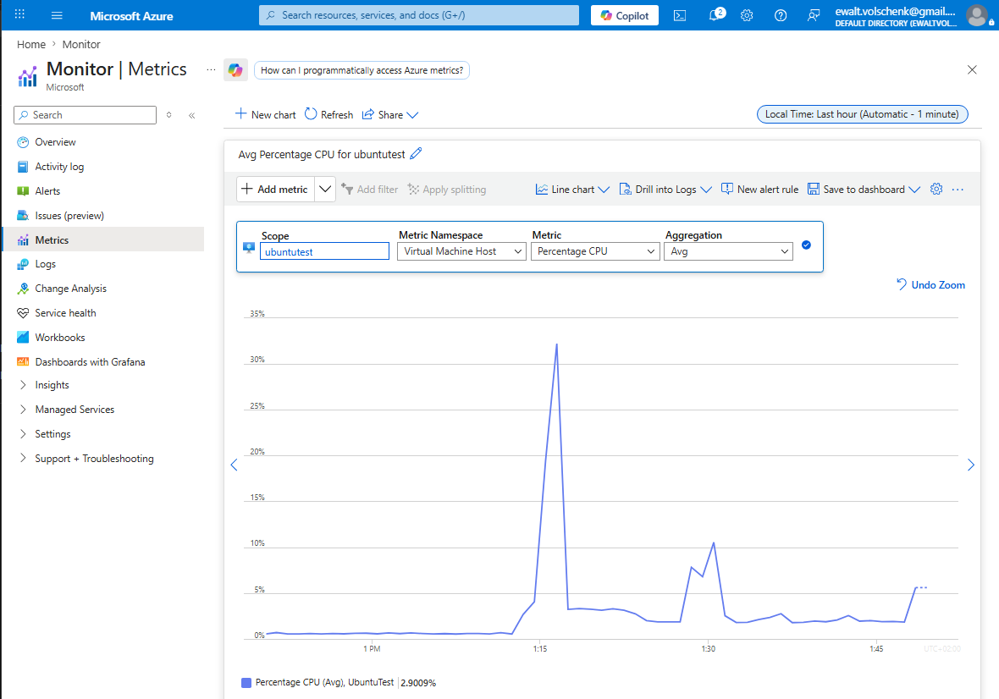

In 1–2 sentences, describe what the CPU metric is showing and whether the values appear expected for your workload:
The CPU metric shows that the VM isn’t running any meaningful load since CPU usage peaks between 30-35%. These values are expected since the load on the VM is extremely light.

Task 2.2 — Network Metrics (1 Mark)
Still in Metrics Explorer, change the metric to observe network throughput. You should investigate both inbound and outbound traffic.

- What is the unit of measurement for the network metric you selected? Is it what you expected?
- Can you display both Network In and Network Out on the same chart? How would you do this?

[ Screenshot: Network metrics chart — showing inbound and/or outbound traffic ]
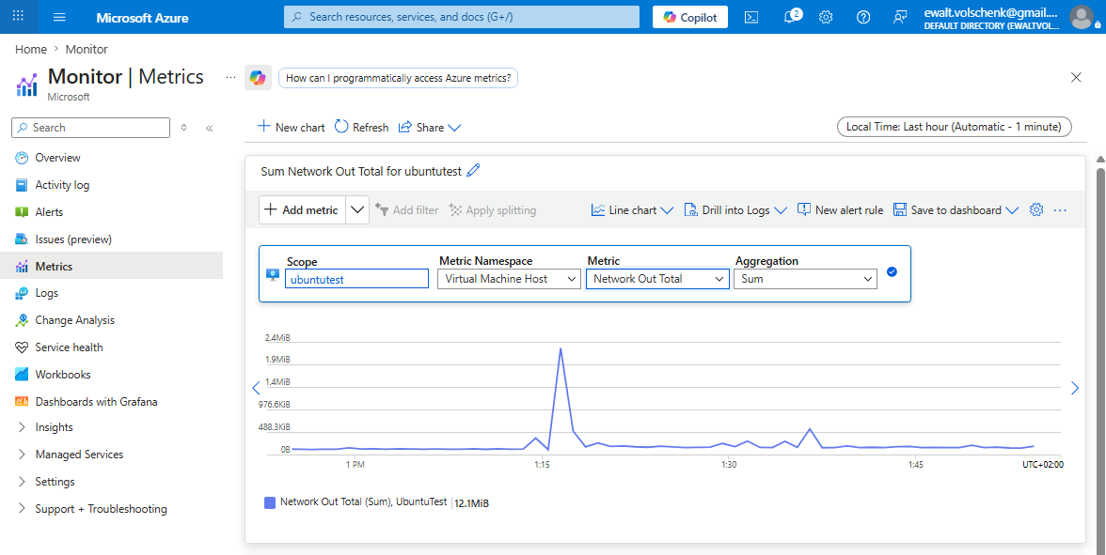

Note any observations about the network traffic pattern you can see:
The network traffic pattern is quite consistent with the occasional spike when the VM is accessed.

Task 2.3 — Disk Metrics (1 Mark)
Finally, explore the disk-related metrics for your VM. Azure exposes separate metrics for disk reads and disk writes.

- Locate both Disk Read Bytes and Disk Write Bytes (or equivalent metrics in your VM configuration)
- Consider: during what activities would you expect disk write activity to be high?

[ Screenshot: Disk metrics chart — showing read and/or write activity ]
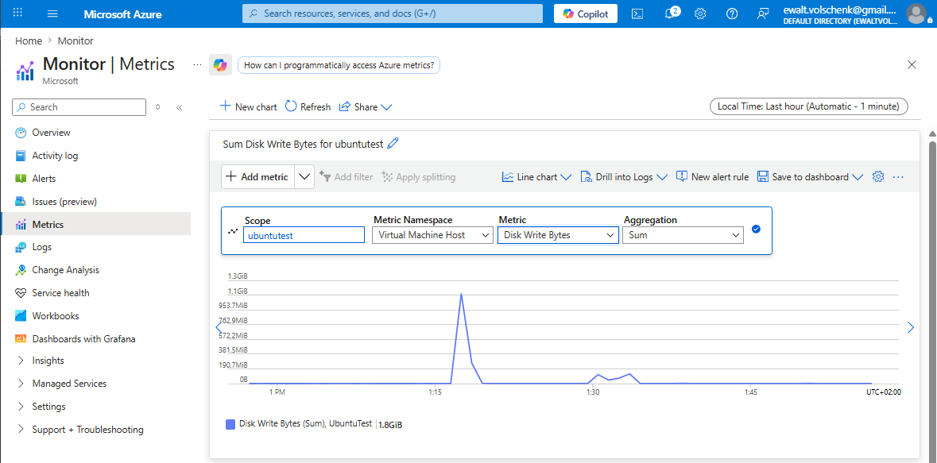

Describe in 1–2 sentences what the disk metrics reveal about your VM's activity:
The VM spiked between 1:15 and 1:30 most likely die to an update package being installed. Other than the spike disk write bytes were consistently low.

Task 3 — Document Your Monitoring Setup (3 Marks)
Monitoring documentation is a critical deliverable in professional environments. A future administrator — or your future self — should be able to understand your setup from the document alone.

Task 3.1 — Monitoring Summary (2 Marks)
Write a structured summary of your monitoring configuration. Your summary should cover all three areas below. Aim for clarity and precision — this is professional technical documentation.

Resources Monitored
List each Azure resource you have enabled monitoring on, specifying the monitoring method used (e.g., VM Insights, Diagnostic Settings) and what data each resource is collecting:

Data Retention and Storage
Where is your monitoring data stored? What retention period applies? How would you access historical data older than the default retention window?
All monitoring data is stored in a Log Analytics Workspace. The default retention period for a Log Analytics Workspace is 30 days at no extra cost. Platform metrics collected through Metrics Explorer are stored separately in the Azure Monitor metrics database and retained for 93 days by default.To access historical data after the default retention window, you can extend the workspace retention period in the Log Analytics Workspace settings.

Metric Observations
Summarise what you observed across the three metrics reviewed in Task 2. Were any values unexpected? What might cause anomalies in these metrics in a production environment?
What I observed is that the three metrics are quite low due to not running any meaningful workload on the VM. There were a few spikes which can be attributed to update packages being installed automatically or perhaps scans by Defender for Cloud.

Task 3.2 — Extension: Configure an Alert Rule (1 Bonus Mark)
Extension Task
This task is optional but provides an opportunity to demonstrate deeper understanding.
Configure at least one Azure Monitor Alert Rule on your VM or network resource.
The alert should have a meaningful threshold — for example, triggering when CPU exceeds 80% for 5 minutes.
Document your alert logic: what condition triggers it, what action does it take, and why you chose that threshold.

[ Screenshot: Configured alert rule — show condition, threshold, and action group ]
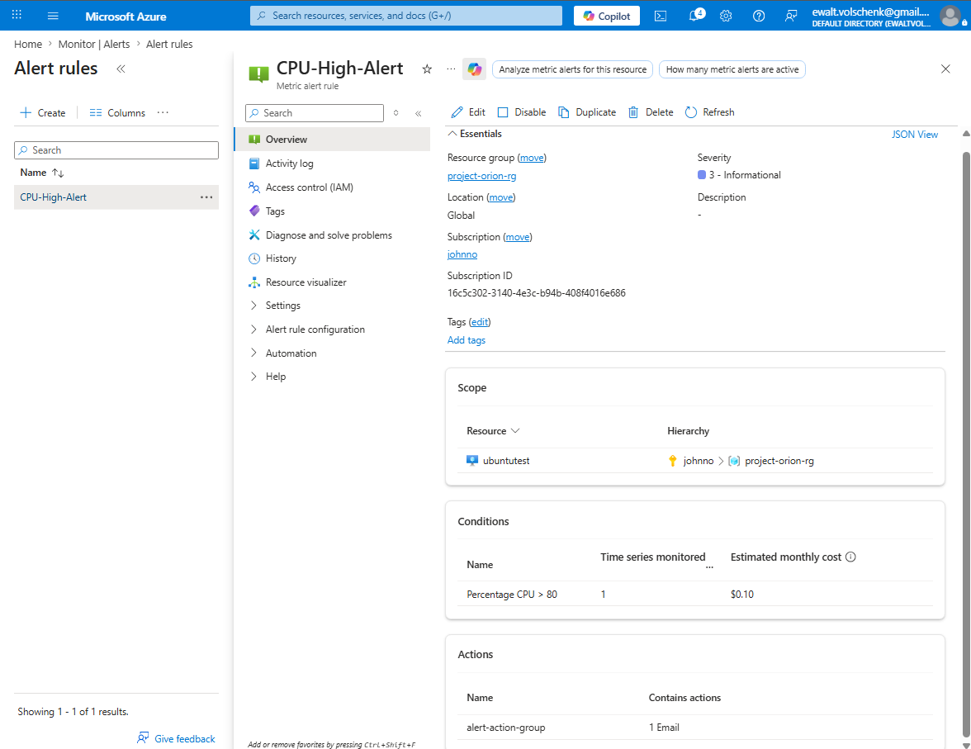

Explain the alert rule you configured and the reasoning behind your chosen threshold:
I configured an alert to issue an email alert to the administrator (me) when CPU usage exceeds 80%. I chose this because it leaves space for workloads to use the CPU while preventing excessive usage.

Reflection Questions
Answer these questions thoughtfully. There are no single correct answers — markers are looking for evidence of understanding and critical thinking.

Reflection Question | Your Response
Why is monitoring important in a cloud environment? How does it differ from monitoring on-premises infrastructure? | Monitoring in a cloud environment is essential because resources can scale up and down, and costs accumulate based on usage. Unlike on-premises infrastructure where you have physical access and fixed hardware, cloud monitoring must rely entirely on platform-provided telemetry.
What is the difference between a metric and a log in Azure Monitor? When would you use each? | A metric is a numerical value measured at regular intervals which is ideal for real-time performance monitoring and alerts. A log is a structured or unstructured record of an event that occurred. Logs contain much more detail and are better suited for troubleshooting and auditing. You would use metrics for dashboards and threshold alerts, and logs for investigating specific incidents.
If your VM showed consistently high CPU usage (above 90%) every day at 2am, what steps would you take to investigate? | First I would check the VM's running processes at that time using logs. I would then check if any scheduled tasks are set to run at 2am, such as backups, updates, or scripts. If nothing explains it I would review the NSG logs and sign-in logs for any suspicious activity.
How could monitoring data be used to make cost-optimisation decisions in Azure? | If CPU and memory metrics consistently show a VM running at under 10% utilisation, that indicates the VM is over-provisioned and could be downsized to a cheaper solution.

Marking Criteria
Use this table to check your submission before submitting.

Task | Marks | Evidence Required
1.1 Enable Azure Monitor on VM | 2 | Screenshot of Monitor enabled on VM resource
1.2 Enable Monitoring on Network Resources | 2 | Screenshot showing NSG/VNet diagnostics
2.1 CPU Metrics Review | 1 | Screenshot of CPU usage chart with annotations
2.2 Network Metrics Review | 1 | Screenshot of network in/out metrics
2.3 Disk Metrics Review | 1 | Screenshot of disk read/write metrics
3.1 Monitoring Documentation | 2 | Written summary with all screenshots included
3.2 Alert Configuration (Extension) | 1 | Screenshot of configured alert rule
TOTAL | 10

Submission Checklist
All screenshot placeholders have been replaced with real screenshots from your Azure environment.
Each screenshot clearly shows your resource names and Azure subscription context.
Written responses are your own words — not copied from documentation.
Reflection questions have been answered with evidence of understanding.
The document has been saved as a .docx or .pdf and submitted via the course portal.

Useful References
The following official documentation may help — but always explore the Azure Portal first before consulting documentation:

- Azure Monitor overview — docs.microsoft.com/azure/azure-monitor/overview
- Enable VM Insights — docs.microsoft.com/azure/azure-monitor/vm/vminsights-enable-overview
- Metrics Explorer — docs.microsoft.com/azure/azure-monitor/essentials/metrics-getting-started
- Diagnostic settings — docs.microsoft.com/azure/azure-monitor/essentials/diagnostic-settings
- Azure Monitor Alerts — docs.microsoft.com/azure/azure-monitor/alerts/alerts-overview

Tip: The Azure Portal's built-in 'Learn more' links on each blade are often the fastest route to relevant documentation.

